#### PRIJAVA / *REGISTRATION FORM*

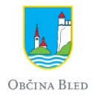

##### SIMPOZIJ / *SYMPOSIUM*

**28–3o september, 2016**

Kranj, Slovenija / *Slovenia*

|  |
| --- |
| Ime in priimek / *Name and surname*: |
| Inštitucija / *Institution*: |
| Naslov, drugo / *Postal address, other contacts*: |
| **E-naslov / Email:** |

|  |  |
| --- | --- |
| Prijavljam / *I am interested in*:  - predavanje / *oral presentation*  - plakat / *poster presentation*  - udeležba / *participation* | Ekskurzija / *Excursion*:  2. dan / *Day 2*  3. dan / *Day 3* |

**PREDAVANJE IN/ALI PLAKAT**

***oral presentation and/or poster presentation***

|  |
| --- |
| **Naslov prispevka / Title of contribution:** |
| Avtor (inštitucija) *1* , avtor (inštitucija) *2*, … /*Author (affiliation)1, Author (affiliation)2, …* |
| Besedilo (150–250 besed) / *Text (150–250 words)*: |

Prijavo pošljite na elektronski naslov **/** *Registration form should be sent by email*: [slavs.symposium@zvkds.si](mailto:slavs.symposium@zvkds.si)

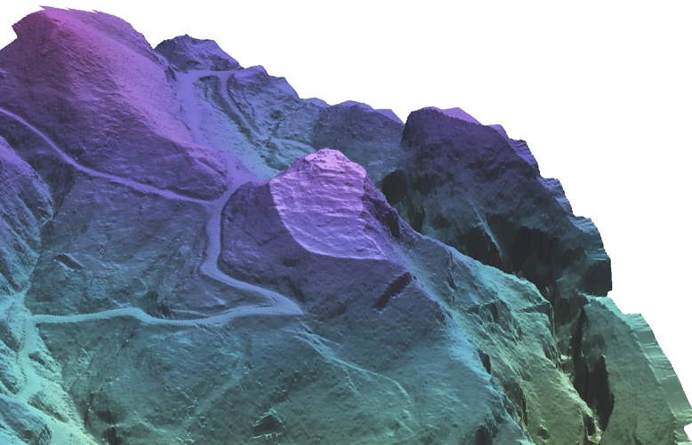

Rok prijave za predavanja in plakate /

*Deadline for abstract submission*

**9. 5. 2016**.

Rok prijave za slušatelje/

*Registration deadline for audience*

**10. 9. 2016**.